FRIGO TOP FT38

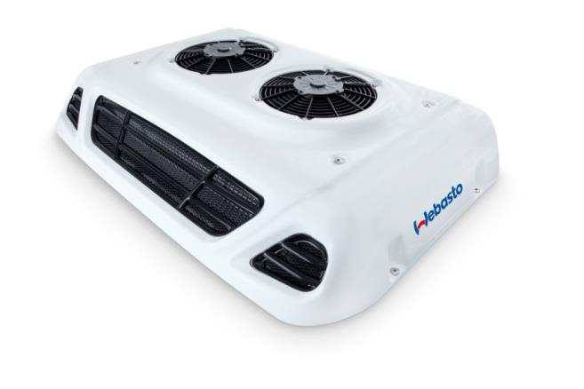 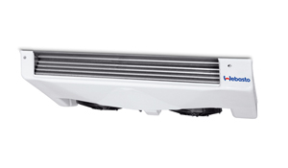

**H**

**W**

**L**

**W1**

**H1**

**L1**

|  |
| --- |
| **Dimensionne / Dimensions**  **Dimensions / Maß**  **Dimension** |
| L | 1115mm |
| W | 663mm |
| H | 194mm |
| http://www.autoera.lv/published/publicdata/JUKKASHOP/attachments/SC/images/weight.png | 28 |

|  |
| --- |
| **Dimensionne / Dimensions**  **Dimensions / Maß**  **Dimension** |
| L1 | 1000mm |
| W1 | 500mm |
| H11 | 157mm |
| http://www.autoera.lv/published/publicdata/JUKKASHOP/attachments/SC/images/weight.png | 12.5 |

|  |  |
| --- | --- |
| R404a | R404A |
| **Potenza frigorifiera**  **Puissance frigorifique**  **Cooking power**  **Kuhlerleistung**  **Potencia frigorifica** | **Potenza frigorifiera**  **Puissance frigorifique**  **Cooling power**  **Kuhlerleistung**  **Potencia frigorifica** | **Portata aria**  **Débit d’air**  **Air flow**  **Luftmenge**  **Capacidad aire** | **Volume cella**  **Volume du compartiment**  **Compartiment volume**  **Kuhlraum Volumen**  **Volumen camara** | **Assorbimento**  **Absorption**  **Rated power**  **Aufnahme**  **Absorcion** |
|  |  | m3/h | m3 | Amp |
|  |  |  |  |  |
| 3800W |  | 1740 | 13 | 36 |
|  | 1800w | 1740 | 10 | 36 |